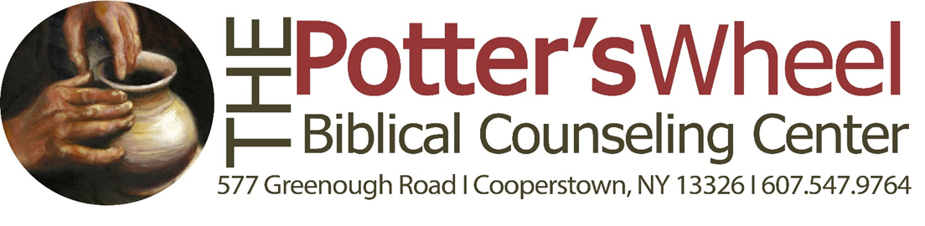

The Potter’s Wheel Biblical Counseling Ministry
Consent to Counsel

Welcome to Community Bible Chapel’s Biblical Counseling Ministry. Our goal is to provide you with Biblical counseling that will help you meet the challenges of life in a way that will please and honor the Lord Jesus Christ and allow you to enjoy His love and plans for your life.

We are confident that the Bible has all of the information necessary for life and godliness (2 Pet. 1:3). We believe that the Bible addresses, at least in principle, all the problems that a person might face in life. Our counselors are either certified by the Association of Certified Biblical Counselors (ACBC) or are in the certification process. We, by design, are not certified by the state of New York. All counseling will be done under the supervision of certified counselors. Our counselors are not infallible, nor do they pretend to know all there is to know about Biblical teaching and its applications to life, but they are well equipped and competent to help people change. (Please note that we do not give medical or legal advice). We are devoted to training Biblical counselors; this means that the counselor may have one to two people observing him/her in the counseling session.

Confidentiality is an important aspect of the counseling process, and we will carefully guard the information you entrust to us. There are certain situations, however, when it may be necessary for us to share certain information with others: when a counselor is uncertain of how to address a particular problem and needs to seek advice from another pastor or elder in this church; when a counselee attends another church and it is necessary to talk with his or her pastor or elders; when there is a clear indication that someone may be harmed unless others intervene; or when a person persistently refuses to renounce a particular sin and it becomes necessary to seek the assistance of others in the church to encourage repentance and reconciliation (see Proverbs 15:22, 24:11; Matthew 18:15-20). Please be assured that our counselors strongly prefer not to disclose personal information to others, and they will make every effort to help you find ways to resolve a problem as privately as possible.

In order to ensure that any conflict which may arise between counselee and counselor be resolved in a Biblically faithful manner, we require, that all our counselees agree that any dispute will be settled by mediation within the church according to the principles of Scripture and the authority of the local church.

Having clarified the principles and policies of our counseling ministry, we welcome the opportunity to minister to you in the name of Christ and to be used by Him as He helps you to grow in spiritual maturity and prepares you for usefulness in His body. If you have any questions about these guidelines, please talk with one of our pastors. If these guidelines are acceptable to you, please sign below.

Signed _______________________________________ Date ________________________

